DBMS Practical No.: 11

**Name: yash ajay magar**

**Experiment No 11: Execute queries using string functions**

Exercise:

1. Write output of the following queries.

2. Select concat (‘Jay’ ‘IITB’) from Dual;

3. Select ltrim (‘Shreya’,’s’) from Dual;

4. Select upper(‘raj’) from Dual;

5. Select rpad (“HR’, 10, ‘*’) from Dual;

2. Select concat (‘Jay’ ‘IITB’) from Dual;

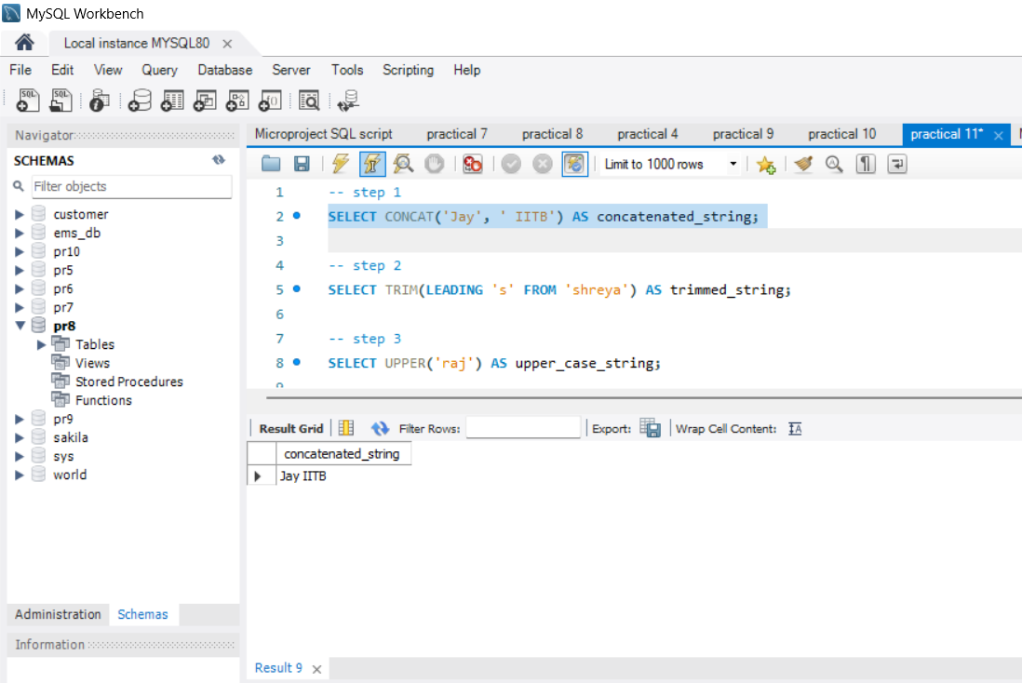

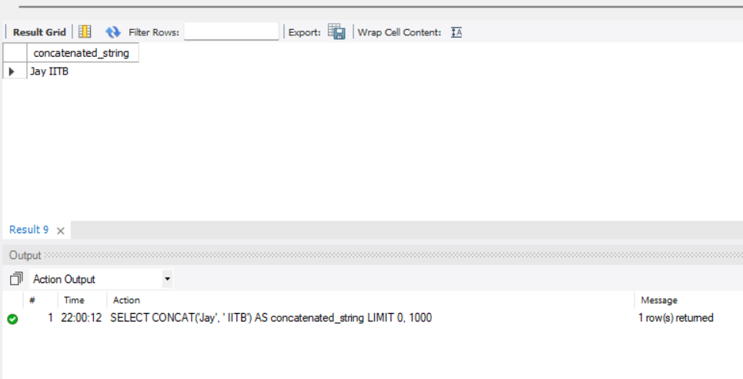

3. Select ltrim (‘Shreya’,’s’) from Dual;

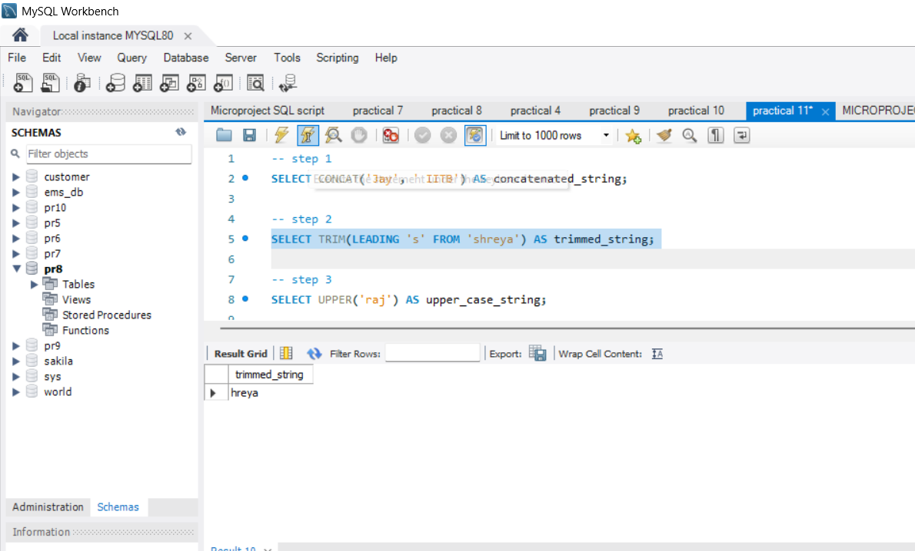

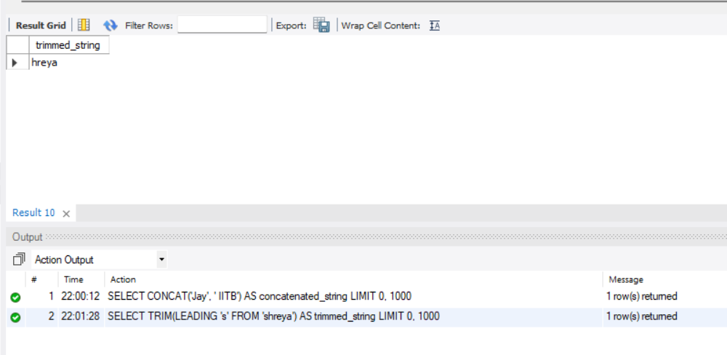

4. Select upper(‘raj’) from Dual;

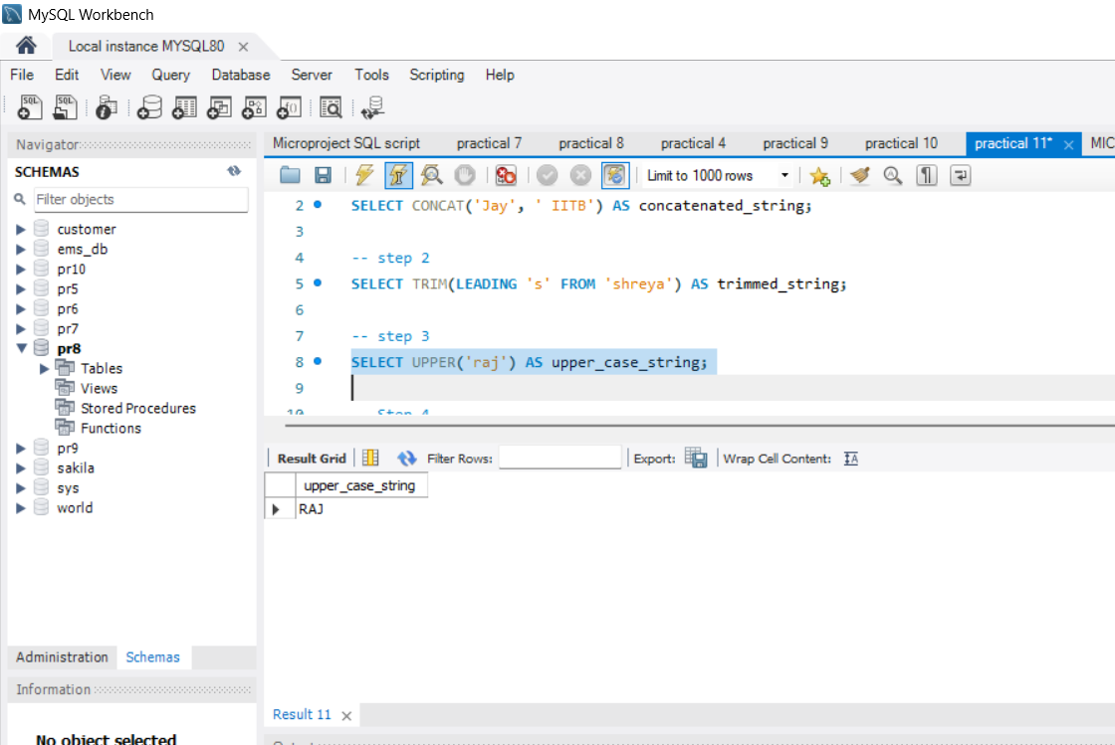

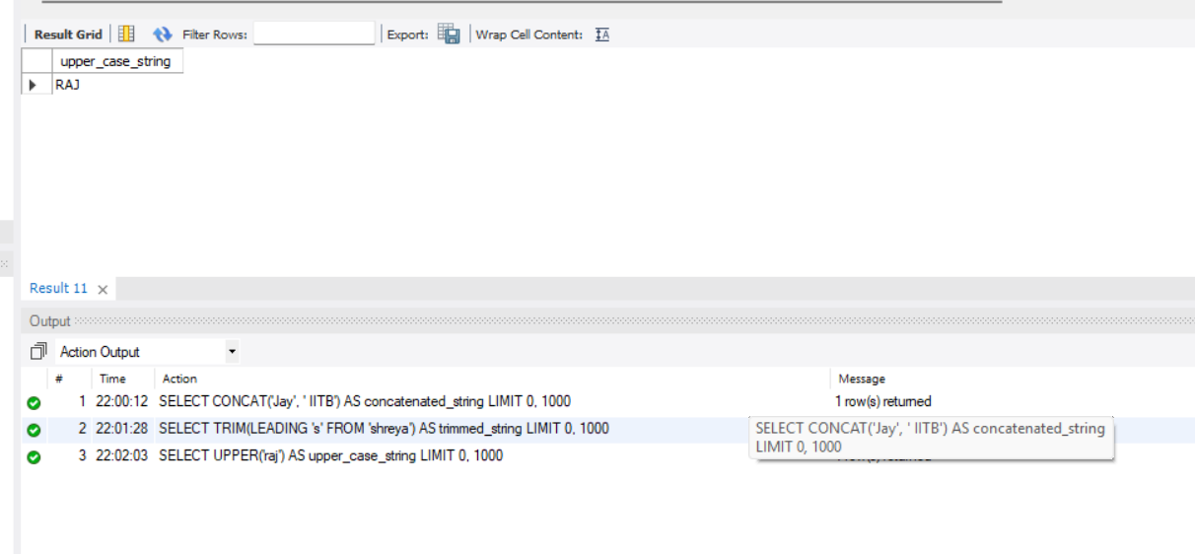

5. Select rpad (“HR’, 10, ‘*’) from Dual;

